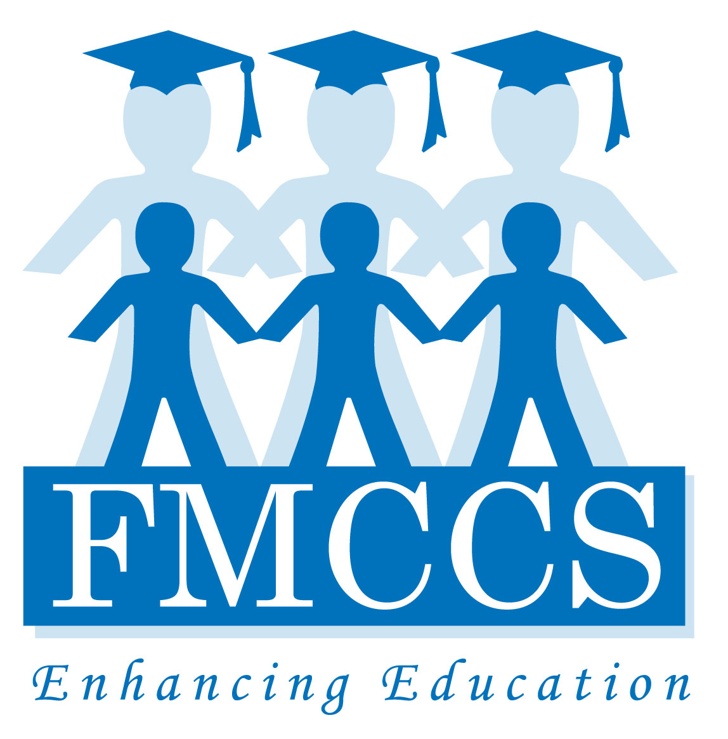
_{FOR IMMEDIATE RELEASE}
CONTACT: Sara Neeley
Phone: 812-330-7700
Email: sneeley@mccsc.edu
Website: http://www.mccsfoundation.org
Facebook: http://www.Facebook.com/IdRatherBeReading

The Foundation of Monroe County Community Schools
Invites You to a Special Stay-At-Home Event this New Year’s Eve to support Literacy in all MCCSC schools
Bloomington, IN – December 5, 2011—The Foundation of Monroe County Community Schools (FMCCS) is taking a unique approach to fundraising this New Year’s Eve. Traditionally, the Foundation has hosted a New Year’s Eve party to raise funds to support educational programs. This year, the Foundation has designed a virtual party and is inviting you to stay home, read, and blog with our virtual family and guests about what you are reading. Party guests are encouraged to use the money they would have spent going out to make a donation to the FMCCS.
The entire community is invited! In a season filled with too much to do, the FMCCS board has recognized this unique concept as an opportunity to engage the Bloomington community in an evening focused on the importance of literacy. A virtual party enables everyone, even kids, to join in the fun!
Please check out our leveled reader invitation on You Tube or in pdf from the FMCCS website or on the Facebook Page (IdRatherBeReading).
The purpose of this non-event is to educate our community on the importance of literacy. Today, 30% of third grade students in MCCSC schools are not reading at grade level. The Foundation along with the MCCSC is committed to reducing this number by 5% each year, and we are making progress. Donations to this event will be used to work towards this goal by providing educators the materials, training and tools they need to ensure that all of our students read at or above grade level. Regardless of how much money we raise, this campaign will help bring awareness to this issue, and hopefully get parents reading more with their kids,” says Sara Neeley, Executive Director of the FMCCS.
Donations of $100 or more will receive a special New Year’s Eve “Stay-At-Home” kit to help design your New Year’s Eve home party. Then, on New Year’s Eve, guests can connect to the Page family through the FMCCS blog and their Facebook page to share their reading adventures.

The Foundation of Monroe County Community Schools serves the students and educators of Monroe County Schools by providing resources to improve and enhance the educational development of all MCCSC students. The Foundation is a 501(C)(3) organization managed by a board of twenty-four committed community members. http://www.mccsfoundation.org
###
For More information about this event contact Sara Neeley, Executive Director of FMCCS at 812-330-7700.

